**Nexa App – Deployment & User Guide**

**1️⃣ Build the App in Android Studio**

1. Open the **Nexa** project in **Android Studio**.
2. Go to **Build → Generate APK**.
3. After the build completes, the APK file will be located at:
4. root/app/build/outputs/apk/debug/debug.apk

**2️⃣ Install the APK on an Android Device**

1. Transfer the **debug.apk** file to your desired Android device  
   (via USB cable, email, or any file-sharing method).
2. On the Android device, tap the **debug.apk** to install.
3. If prompted, enable **Install from Unknown Sources** in Settings.

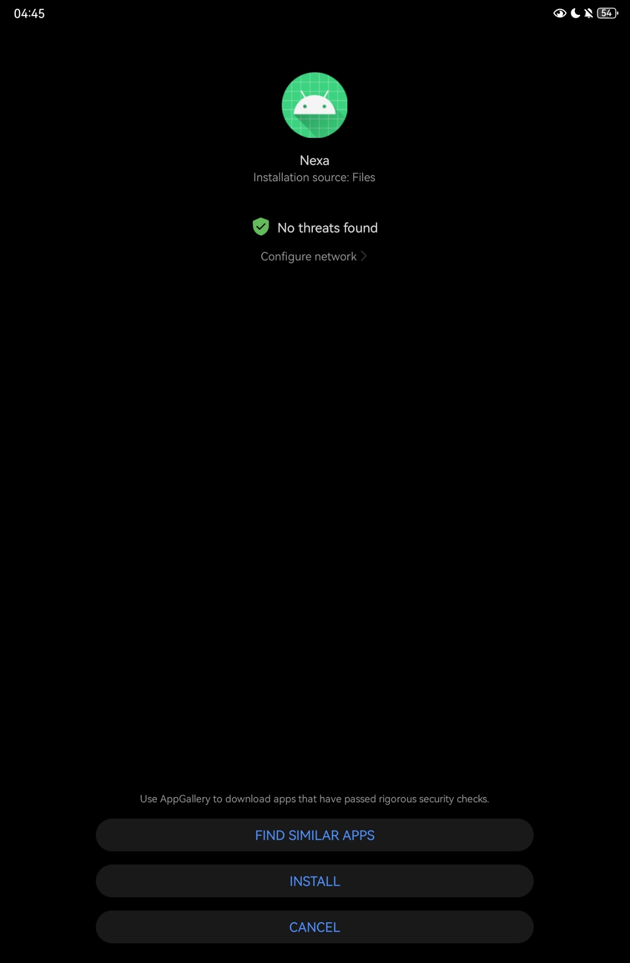

**3️⃣ First Launch & Permissions**

1. Open the **Nexa** app on your device.
2. When asked to allow **location permissions**, choose:
   * **“Allow only while using the app”** or
   * **“Only this time”**.

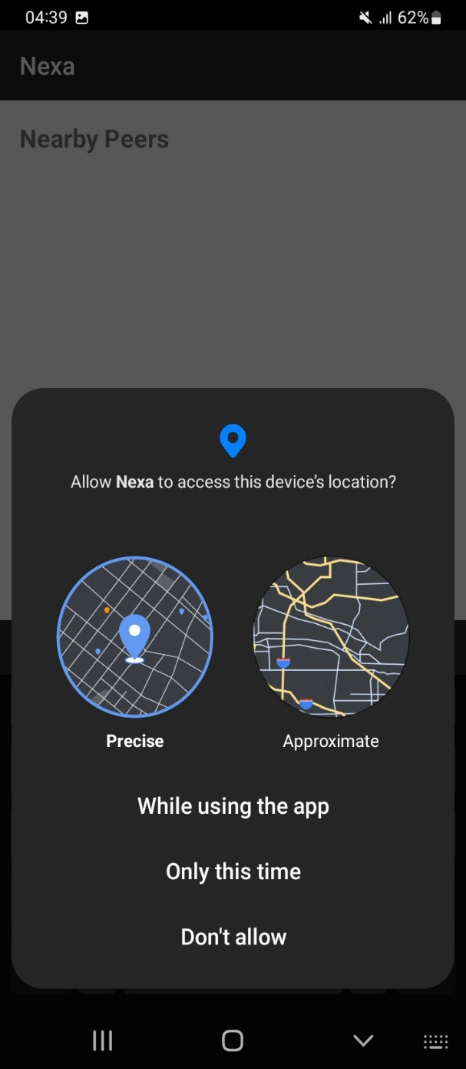

**4️⃣ Welcome & Profile Setup**

* The **Welcome Page** displays a greeting and a sign-on form.
* Enter:
  + Your **Username**
  + An optional **Bio** for your profile.

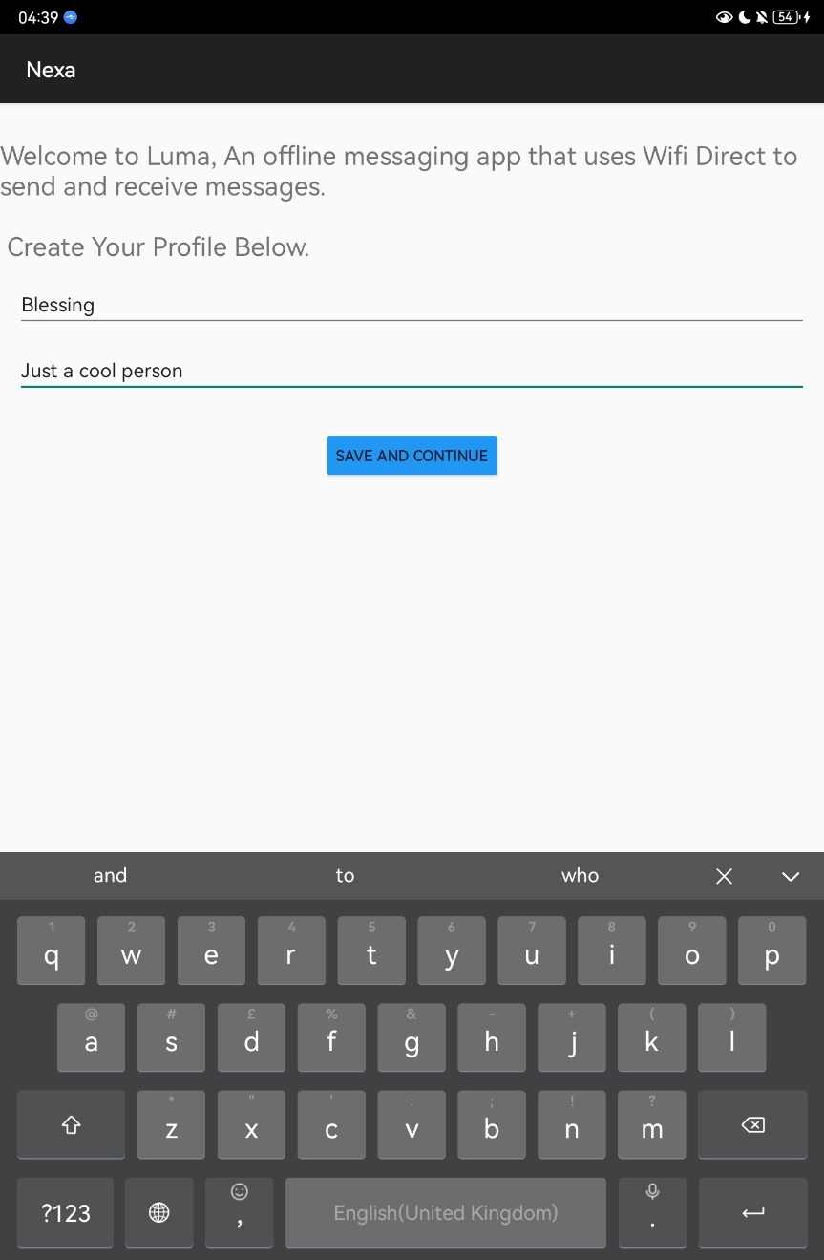

**5️⃣ Connect with Peers (Wi-Fi Direct)**

1. On the **Home Page**, tap **Scan** to search for nearby peers using **Wi-Fi Direct**.
2. A list of available devices will appear.
3. Tap **Connect** on the device you want to pair with.

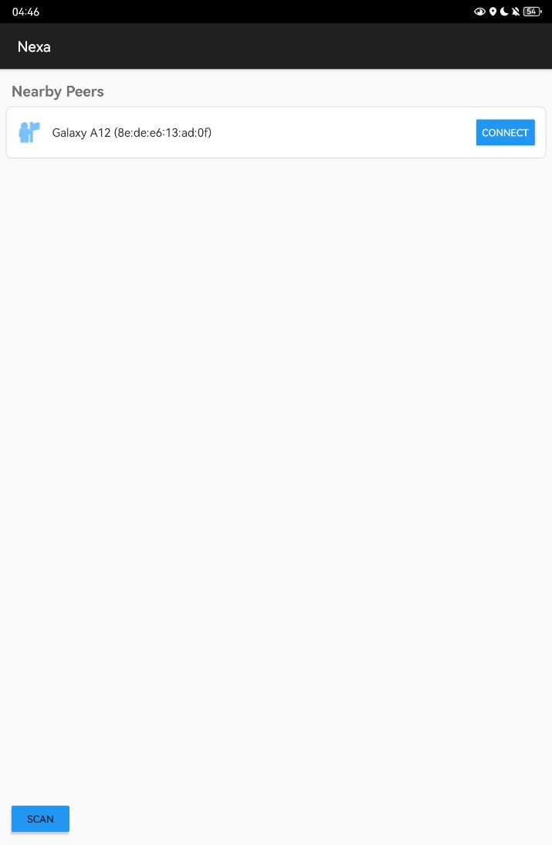

**6️⃣ Accept the Connection**

* On the **Client side**, a notification appears asking to confirm the connection.
* The client taps **Yes** to accept.
* Once accepted, a **Chat Page** opens.

**7️⃣ Start Chatting**

* Use the chat page to exchange text messages in real time.
* At the top of the chat screen, you can see:
  + Your **Username**
  + Your **Device ID**
  + Your **Role** (**Owner** or **Client**).  
    